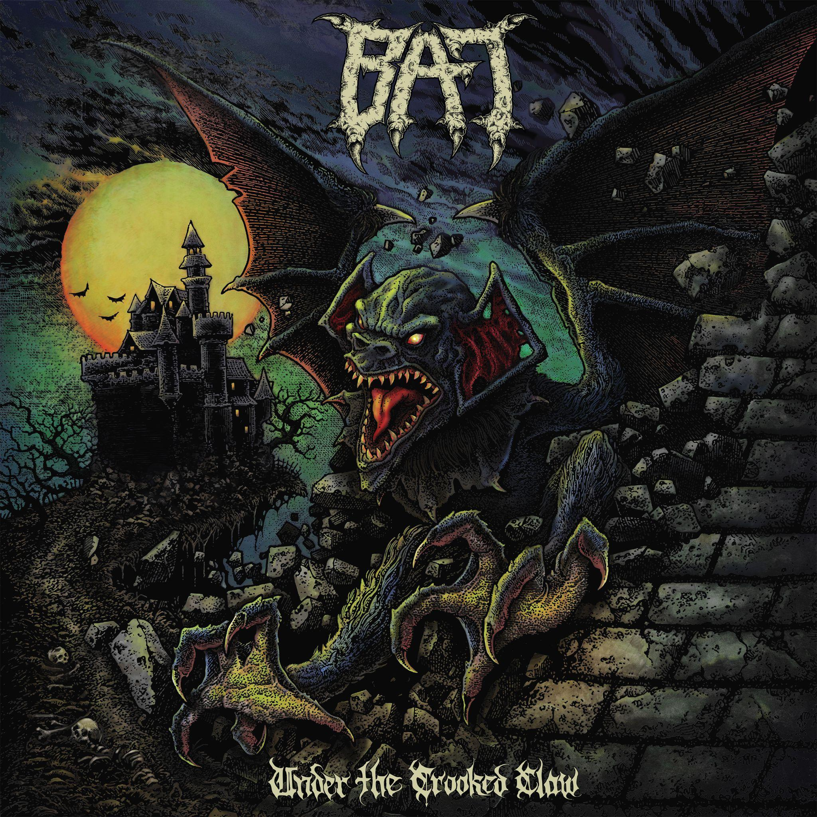
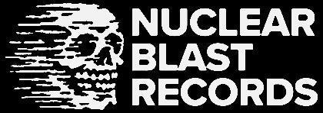

BAT
Under the Crooked Claw

Release Date: May 17, 2024

Line up: | BAT online:
Ryan Waste | Lead Vocals, Bass  Nick Poulos | Lead Guitar  Chris Marshall | Drums | www.facebook.com/bewareofthebat  www.instagram.com/bewareofbat/  www.youtube.com/channel/UCYmwNm85FjRqyTIUD7lPFsw?app=desktop
Our attraction to horror is visceral and undeniable. Racing pulse and sweating palms, and yet you can’t turn away. It’s shocking . . . yet also exhilarating. It’s what keeps us coming back for more, that rush of fear.

Richmond, Virginia metal-punk trio BAT have been delivering their own blood-spattered horror since ascending from the underground a decade ago on a dark, leather-winged trajectory. The brainchild of MUNICPAL WASTE guitarist, Ryan Waste, BAT’s origins actually go back to 2008 when Waste and former D.R.I. drummer, and Texas native, Felix Griffin, hatched the idea of working together. “We’d see each other when I’d pass through Texas,” says Waste, “and we talked about doing a project where I played all the instruments—guitar, bass, and vocals— and he would drum. We both love Discharge and Celtic Frost and we wanted to do something real straightforward, no frills.”

BAT remained a shadowy concept more than an actual band until Waste enlisted guitarist Nick Poulos from VOLTURE, the heavy metal project he’d been doing in addition to his MUNICIPAL WASTE duties. As VOLTURE ran out of steam in 2013, BAT took flight with Waste and Poulos crafting a sonic origin story that grew from the original ‘straightforward, no frills’ ethos into something rougher, darker, and laden with an approach that’s straight out of the down-and-dirty side of the New Wave of British Heavy Metal. With Nick’s soaring lead playing, Ryan returned to his distorted bass roots, all rounded out by Felix’s relentless battery.

BAT’s 2013 debut, Primitive Age EP, was recorded on analog reel-to-reel tape in Richmond at the trio’s first rehearsals with Texas-based Griffin. “That first session was just meant to be a demo tape,” says Waste. “We hardly overdubbed anything and kept it loose, as the songs were just taking form. That primitive style became the way the band rolled.” This raw demo was nonetheless issued on cassette by Tankcrimes before BAT had even played a show. BAT made their first live appearances opening three shows for SATAN (UK) in April 2014. With more touring to follow, these demo songs matured into their own after being put to the test live. They re-recorded the five demo tracks along with seven new tunes that would become their 2016 debut full-length album Wings of Chains (Hells Headbangers). They released a music video for their namesake song also known as ‘Beware of the BAT’ which featured a fully fabricated costume designed by Margaret Rolicki (GWAR) based on the album artwork by Christoph Breit (Infected Arts).

After a series of tragic personal events befell Griffin, he was forced to depart the band in 2017, with his swansong being the Axestasy EP (recorded in 2017, released in 2019). To replace Griffin, BAT tapped local drummer Chris Marshall, a vet of D-beat outfit NO TOMORROW, adding the perfect punk foil to Poulos and Waste’s speed metal riffing. “I’ve always preferred punk drumming with a single kick for our style,” says Waste. “I think his playing suits the band and Chris does it with a lot of soul.”

Once Marshall joined BAT in 2017, the three were finally able to rehearse on a regular basis since all members were living in the same town for the first time. They were now available to pick up and play gigs on demand, and ultimately made it to Europe supporting NAPALM DEATH right up until the pandemic closed the world down in 2020. Given the opportunity to woodshed uninterrupted, BAT attacked what would become album number two. “The songs came together incredibly easily and quickly, like something you’d see in a movie,” Waste explains. “We were writing together as a three-piece—with drums finally in the room—and the ideas just came flowing out. I’d go home and write lyrics immediately afterwards, the inspiration was palpable.”

In June 2021, the trio decamped to Philadelphia where Arthur Rizk recorded the basic tracks for the new BAT full-length. Yavé Rust tracked lead guitars and vocals later when the band was back in Richmond, ultimately mixed by Rizk. With a newly inked deal with Nuclear Blast and a new drummer, BAT’s sophomore full-length would be a significant step forward, and Waste and Co. were determined to make an impact.

Under the Crooked Claw does just that, right from the perfect mood-setting opener, “Una Torcia Illumina Il Cielo,” courtesy of Italian horror soundtrack maestro Fabio Frizzi. The brief haunting synth piece is like a measured descent into a dank crypt where the living dead erupt with in a fury in the raging ‘Vampyre Lore.’ Eleven more tales of terror follow in rapid succession with a grisly theme throughout. “I feel like the songs could be short horror stories of their own,” notes Waste of his lyrical efforts. “The first single, ‘Rite for Exorcism,’ is basically a reverse exorcism, where the girl is accepting the demon into her and she turns it on the preacher. Evil wins in this case.”

Waste is known for his love of the NWOBHM, but with BAT, he’s taken that influence in a fresh direction on ‘Under the Crooked Claw’, with its tight, concise songs loaded with punchy choruses and lightning-laced leads. “As big of a heavy metal fan as I am, I think the dirtier side of it fits better with my vocals,” he says. “But we try to push the boundaries in BAT between heavy metal, punk and rock ‘n’ roll to where you can’t quite put your finger on it. Dynamically it all coagulates together with our dirty sound. I call it primitive heavy speed. It’s just the nastiest mix of all of the above.”

And as for any suggestion that BAT is a “side project” for Waste and Poulos, Waste is having none of that. “It’s not just a side project,” he states definitively. “Everything I do is full force and this no different. There’s so much more we want to do with it.”

